NAME:SHRUTI VERMA
REGISTRATION NUMBER:18BCE1005
ACTIVITY DIAGRAM
TOPC:E-CRIME MANAGEMENT SYSTEM
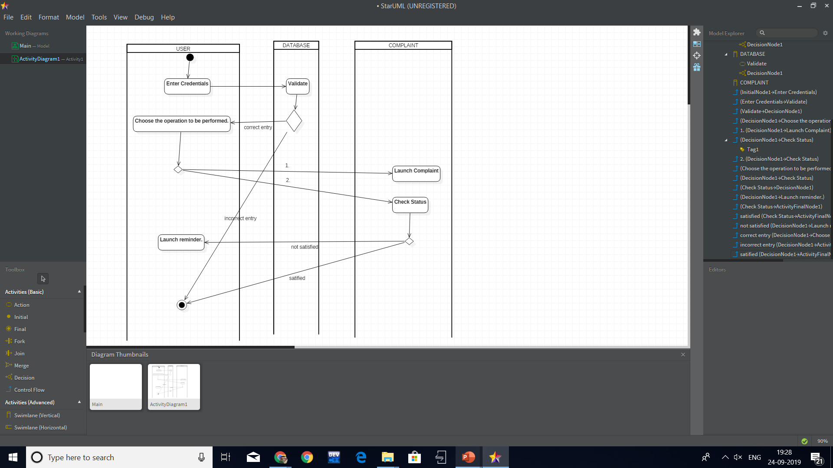

WRT POLICE:
